Advanced Technology Provides Superior Energy-Efficiency, Comfort and Durability

CompositWood Windows offer superior performance because they combine the latest in composite material technology with the best performing glass options. The CompositWood material combines the beauty of wood with superior, rot-proof durability and no-maintenance attributes of vinyl. It’s a superior insulator compared to fiberglass, wood or aluminum. Combine this advanced material with the highest performing glazing, and you get greater energy savings, comfort, and durability over the long run.

- Thermally superior composite material reduces energy-transfer better than wood, vinyl, fiberglass, and aluminum
- More energy-efficiency means greater savings on monthly heating & cooling costs
- Available with highest-performance glass system for maximum savings
- Surpasses ENERGY STAR® energy performance criteria
- CompositWood windows have multiple weather-strip paths with interlocking sash and jambs designed to reduce air infiltration
- More comfort - without air drafts you stay warmer in Winter, cooler in Summer
- Classic wood window design enhances the value and beauty of your home - inside and out
- Premium performance hardware ensures easy cleaning and operation

EXCLUSIVE SUPERCAP™ SURFACE TECHNOLOGY
SuperCap provides a permanent pre-finished surface that performs in the harshest of weather conditions. A lifetime of virtually no-maintenance benefits for homeowners, this tough, capped surface protects against yellowing from ultraviolet light exposure, erosion, chalking and cracking to keep windows and doors looking good over time. The cap brings protective ingredients to the profile surface, where they provide superior weathering performance. Also, the SuperCap surface layer is integral and fusion-bonded into the profile.

BENEFITS OF COMPOSITWOOD

Air tight - exceptionally low air infiltration ratings
High thermal performance to lower heating and cooling bills
Stronger than vinyl or fiberglass
Impact resistant
Less expansion & contraction
Impervious to moisture and rot
Insect free
Beautiful, durable finishes
Better screw retention
Virtually maintenance free
Energy efficient, solid core insulating property
Salt air proof
Retains dimensional tolerances
Energy Star certified
Lifetime warranty

TILT IN DOUBLE HUNG

- Classic wood window designed frame and sash for added curb appeal
- Solid core frame and sash for superior thermal performance
- True sloped sill for fast water run-off and easy cleaning
- Draftblocker™ off-set compression sash design for air-tight seal and added security. Rate of air infiltration - (0.05 cfm/ft2) with minimal operating force
- Light Lift™ balances for easy operation
- Integral off-set balance pockets and multiple weather-strip paths to reduce air infiltration
- Tripled-secured sash & frame corners: mortise & tenon or biscuit joined, chemically fusion-welded, stainless-steel screw fastened
- Tilt in sashes for easy cleaning from inside your home

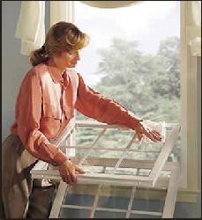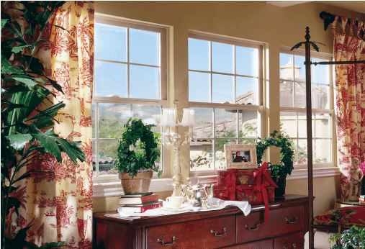

CASEMENT / AWNING
- Classic wood casement window designed frame and sash for an elegant appearance
- Solid core frame and sash for superior thermal performance
- Draftblocker™ compression seal design and multipoint sash locking hardware for incredible air-tight performance and added security. Rate of air infiltration - (<0 .01 cfm/ft2)
- Tripled-secured sash & frame corners: mortise & tenon sash, tongue & groove keyway frame, chemically fusion-welded, stainless-steel screw fastened
- Aesthetically pleasing low profile folding handle, concealed hinge hardware
- Inside mounted weather-stripped screen system deters insects
- 90° sash pivot for easy cleaning from inside your home

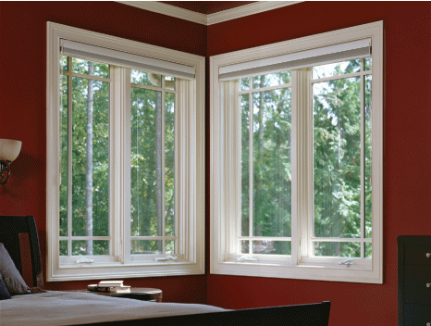

PICTURE

- Solid core frame and sash for superior thermal performance
- 3 picture window options to match your operating window styles:
  - Double Hung sash Casement sash or narrow
  - Direct-Set design for maximum viewing and specialty shaped windows
- Tripled-secured corners:
  - mortise & tenon/biscuit double hung frame, tongue & groove keyway casement frame, chemically fusion-welded, stainless
  - steel screw fastened

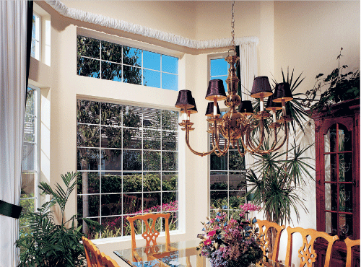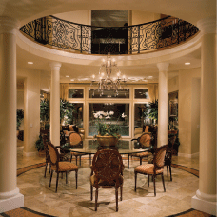

BOWS / BAYS

- 3/4” #1 Eastern White Pine struts allow for unlimited angles from 0 to 55 degrees on bows
- 3/4” #1 Eastern White Pine end jambs (has secondary cover to hide unsightly installation nails and screws)
- Two interior finishes - all wood or vinyl mullions, end fillers, and stops
- Unique weep system directs water away from channels
- 1/4” all-threaded steel rods between struts tie head and seat boards together for added strength
- Foam sealant between struts for added energy efficiency
- Maintenance free vinyl-clad exterior – available in white, adobe and brown
